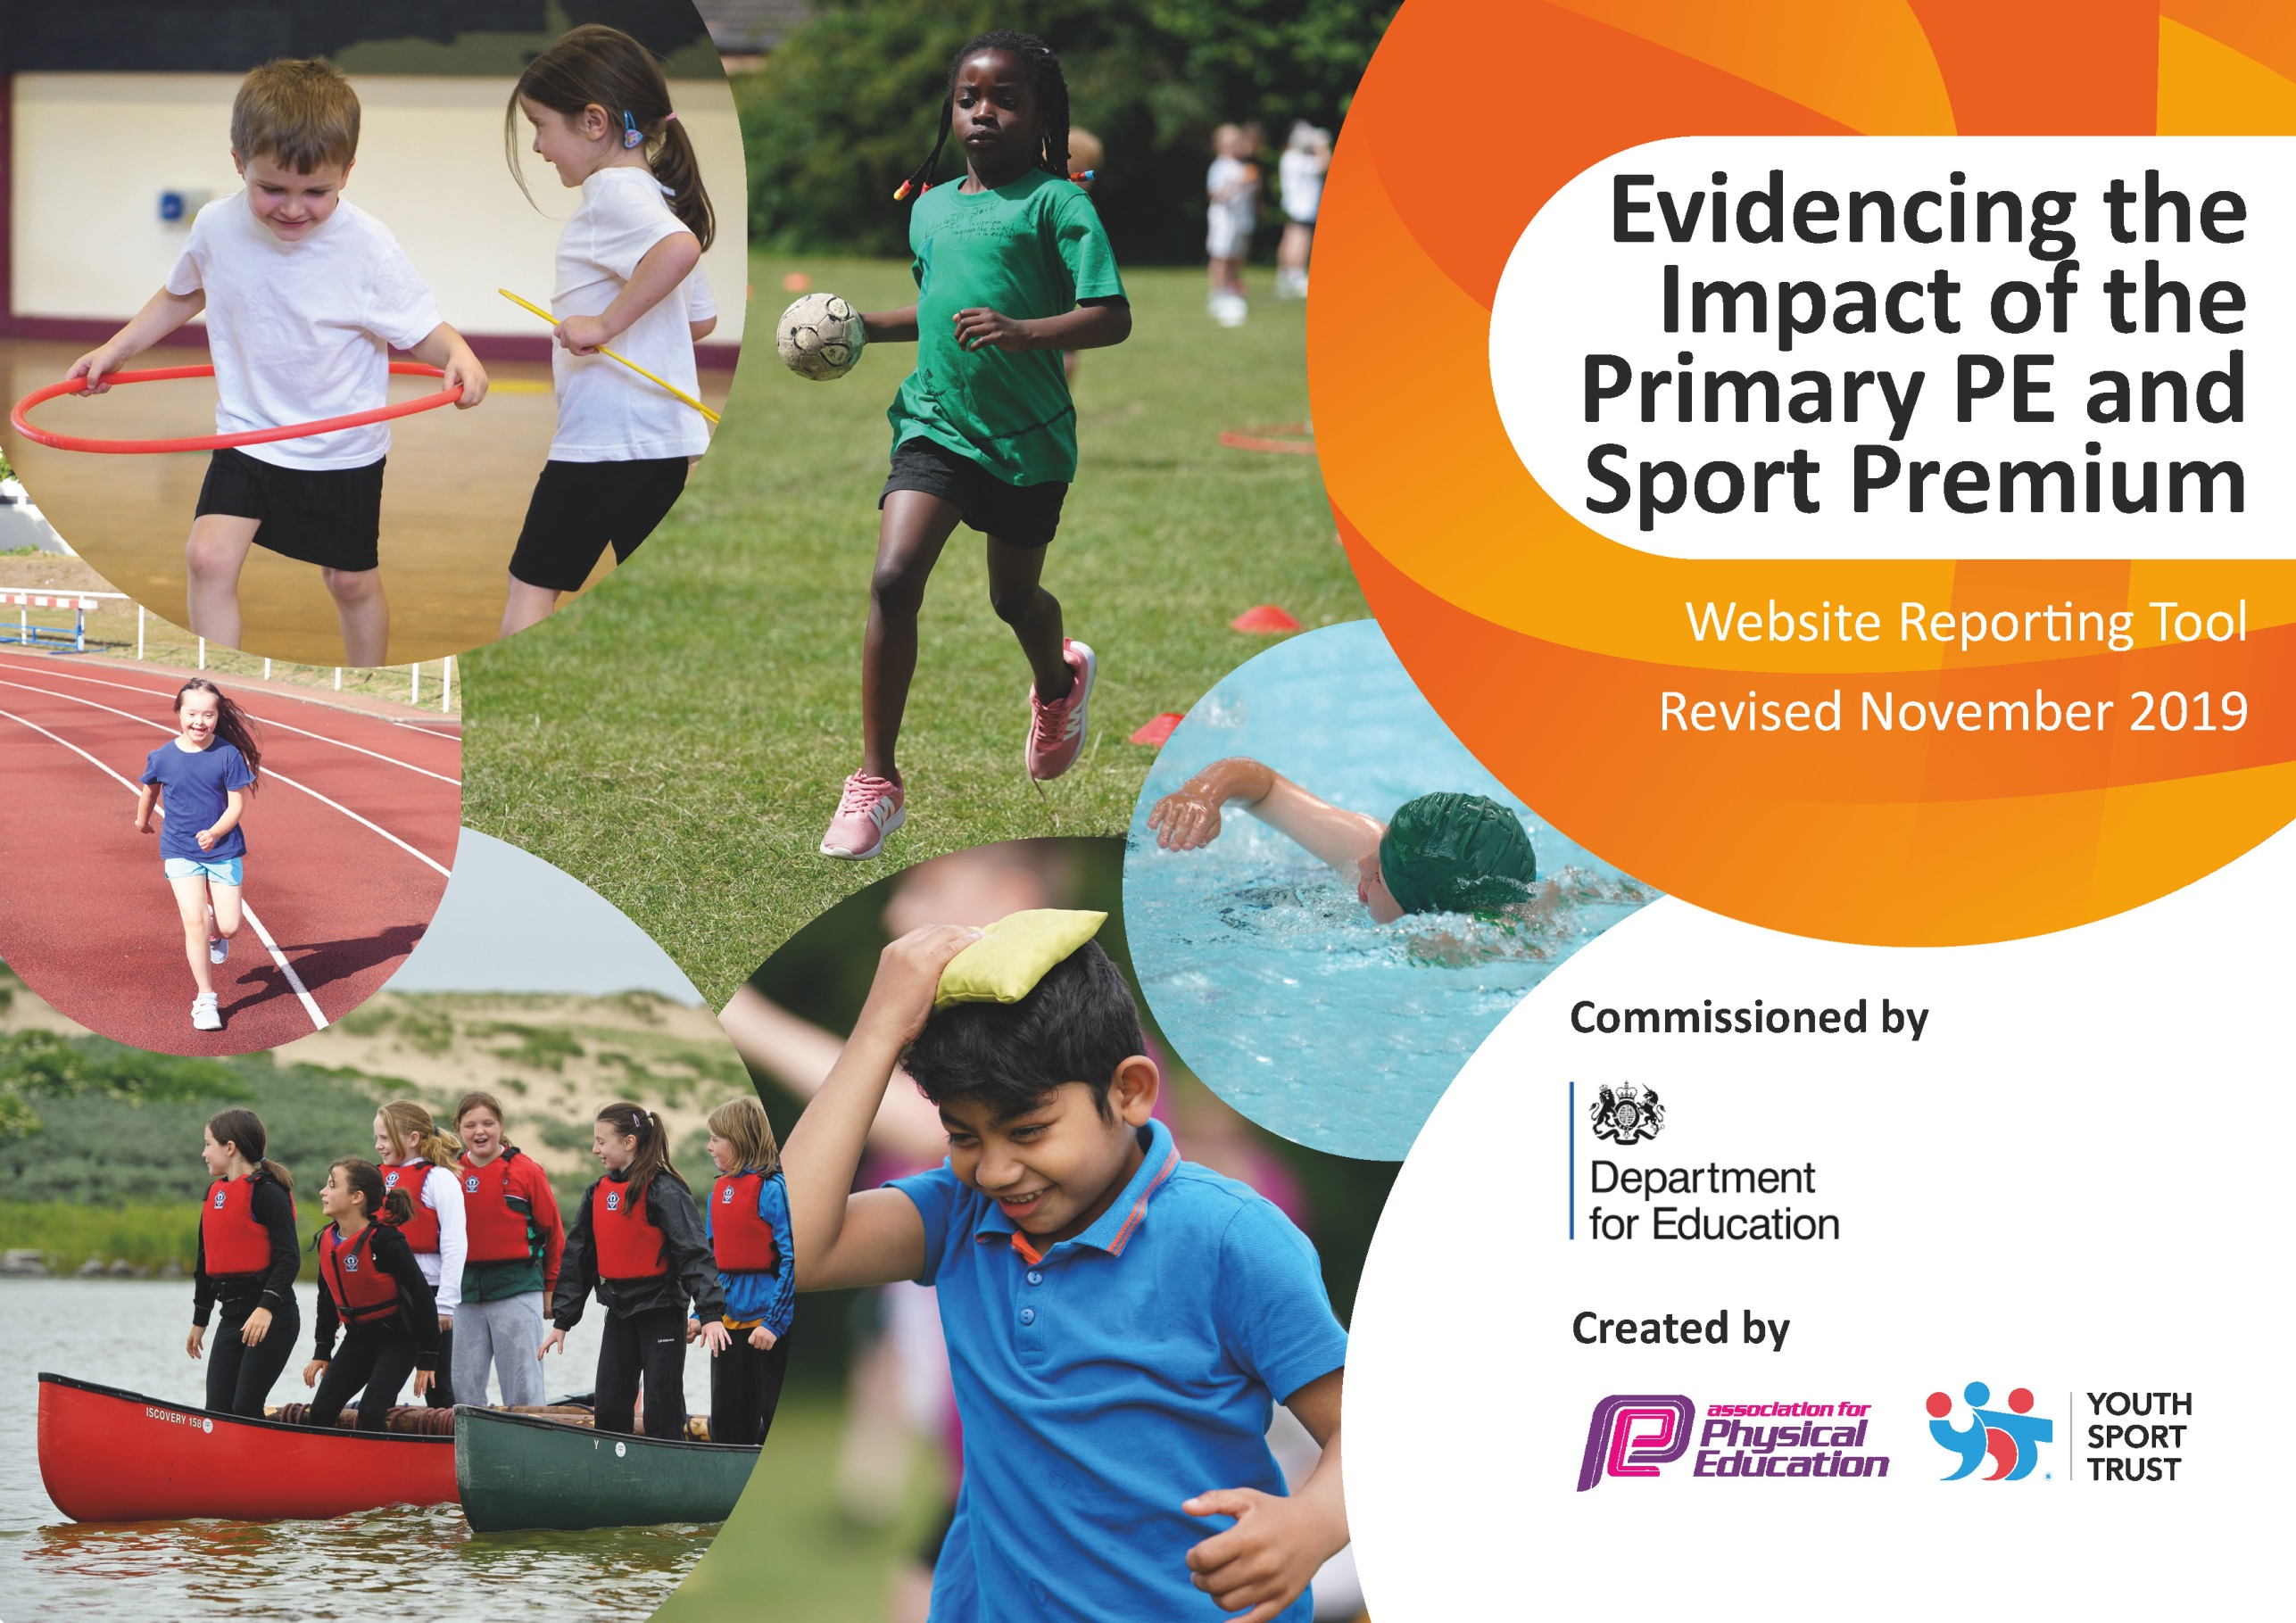
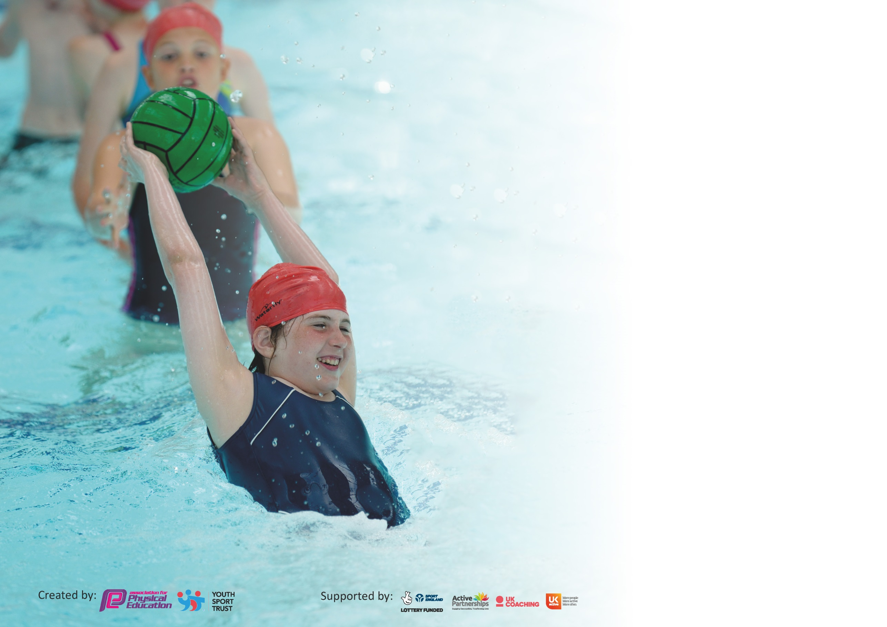

It is important that your grant is used effectively and based on school need. The Education Inspection Framework (Ofsted 2019 p64) makes clear there will be a focus on ‘whether leaders and those responsible for governors all understand their respective roles and perform these in a way that enhances the effectiveness of the school’.

Under the Quality of Education criteria (p41) inspectors consider the extent to which schools can articulate their curriculum (INTENT), construct their curriculum (IMPLEMENTATION) and demonstrate the outcomes which result (IMPACT).

To assist schools with common transferable language this template has been developed to utilise the same three headings which should make your plans easily transferable between working documents.

Schools must use the funding to make additional and sustainable improvements to the quality of Physical Education, School Sport and Physical Activity (PESSPA) they offer. This means that you should
use the Primary PE and Sport Premium to:

- Develop or add to the PESSPA activities that your school already offer
- Build capacity and capability within the school to ensure that improvements made now will benefit pupils joining the school in future years

Please visit gov.uk for the revised DfE guidance including the 5 key indicators across which schools should demonstrate an improvement. This document will help you to review your provision and to report your spend. DfE encourages schools to use this template as an effective way of meeting the reporting requirements of the Primary PE and Sport Premium.

We recommend you start by reflecting on the impact of current provision and reviewing the previous spend.

Schools are required to publish details of how they spend this funding as well as on the impact it has on pupils’ PE and sport participation and attainment by the end of the summer term or by 31st July 2020 at the latest.

We recommend regularly updating the table and publishing it on your website throughout the year. This evidences your ongoing self-evaluation of how you are using the funding to secure maximum, sustainable impact. Final copy must be posted on your website by the end of the academic year and no later than the 31st July 2020. To see an example of how to complete the table please click HERE.

Support for review and reflection - considering the 5 key indicators from DfE, what development needs are a priority for your setting and your pupils now and why? Use the space below to reflect on previous spend and key achievements and areas for development.

Key achievements to date until July 2019: | Areas for further improvement and baseline evidence of need:
South Ribble PE Primary School of the Year 2017  Sainsbury’s School Games Mark (Gold for 4 consecutive years)  high quality PE teaching and coaching in school both as part of curriculum provision and after school club provision.  Confident and skilled teachers and specialist coaching delivered throughout the school.  Children demonstrate high enjoyment of PE lessons.  Whole school is an active school supported by all parts of the school family widening into breakfast and afterschool club.  Lunch time ‘Mini Coaches’ (Year 5 and 6’s) support the infants to become more active and improve fundamental movements with gamesd activities.  Playtime ‘ Y6 buddies’ are on a rota to ensure happy and safe playtimes.  Purchasing of new ‘Handball’ and games equipment to motivate and put an emphasis on a variety of new sports.  New play equipment for each class to have own resources and games for more active play.  A clear assessment system for the infants (Reception, beginning of Year 1 and end of Year 2) is being used effectively to ensure the children have excellent fundamental skills from a young age.  My Personal Best resources from Youth Sport Trust implemented and used as a tool to enhance the social and health areas of PSHE throughout the school. | Assessment tracker for KS2 focusing on applying the fundamental skills to a variety of sports.  Promote use of a running track for school to so that daily running can be established whatever the weather. This will be part of the plan for 2020 – 2021.  Ensure that 30 active minutes is achieved by all pupils (staff will also be involved as part of well-being).  Personal Best ethos developing further into PSHE.  To continue the Sport Committee and School Council role in improving the awareness of PESSPA through the school and its community.

Meeting national curriculum requirements for swimming and water safety.
What percentage of your current Year 6 cohort swim competently, confidently and proficiently over a distance of at least 25 metres?  N.B. Even though your pupils may swim in another year please report on their attainment on leaving  primary school at the end of the summer term 2020. | 100%
What percentage of your current Year 6 cohort use a range of strokes effectively [for example, front crawl, backstroke and breaststroke]? | 95%
What percentage of your current Year 6 cohort perform safe self-rescue in different water-based situations? | 95%
Schools can choose to use the Primary PE and Sport Premium to provide additional provision for swimming but this must be for activity over and above the national curriculum requirements. Have you used it in this way? | No

Action Plan and Budget Tracking
Capture your intended annual spend against the 5 key indicators. Clarify the success criteria and evidence of impact that you intend to measure to evaluate for pupils today and for the future.

Academic Year: 2019/20 | Total fund allocated: £18,000 | Date Updated: 23.07.20
Key indicator 1: The engagement of all pupils in regular physical activity – Chief Medical Officer guidelines recommend that primary school pupils undertake at least 30 minutes of physical activity a day in school |  |  |  | Percentage of total allocation:
 |  |  |  | 11%
Intent | Implementation |  | Impact
Your school focus should be clear what you want the pupils to know and be able to do and about  what they need to learn and to  consolidate through practice: | Make sure your actions to achieve are linked to your intentions: | Funding allocated: | Evidence of impact: what do pupils now know and what can they now do? What has changed? | Sustainability and suggested next steps:
PE and Sport equipment allocated for lunch time active play | Year 5 and 6 buddies and sport leaders to organise the infant and junior boxes with new play equipment bought using the Sport Premium money. | £2000 on new play equipment | Lunch times are far more active with the play equipment. More children involved in daily exercise. | Play equipment has been used well but is now worn. Money will be used next year to replenish the play equipment and for individual classes to have their own equipment boxes to reduce sharing.
More active play for the infants. | Year 5 and 6 trained as buddies and mini coaches to help the infants become more active. | Training the mini coaches is free from teachers in school. | The new mini coaching sessions are very popular with the infants | The mini coaches from Year 5, who will become Year 6, will train and support the new Year 5 mini coaches – this will have to be reviewed in line with the new guidance in September 2020.
Key indicator 2: The profile of PESSPA being raised across the school as a tool for whole school improvement |  |  |  | Percentage of total allocation:
 |  |  |  | 2%
Intent | Implementation |  | Impact
Your school focus should be clear what you want the pupils to know and be able to do and about  what they need to learn and to  consolidate through practice: | Make sure your actions to achieve are linked to your intentions: | Funding allocated: | Evidence of impact: what do pupils now know and what can they now do? What has changed?: | Sustainability and suggested next steps:
Continue to embed the My Personal Best (My PB) resource from Youth Sport Trust – which has a main focus on developing the social and personal health of every child. | Due to the success of My PB themes of last year, each class to choose their theme for every term, linking to the PSHE themes which are to be planned across key stages. | £250 | All staff have enjoyed the freedom to choose their own themes for their class and are beginning to link with the PSHE curriculum. | As this resource is already paid for, no more funding is required. The impact on the school is still very positive, therefore we will be improving its use linked more with the PSHE curriculum PSHE Association)which is £300 for membership
To continue to run charity events with sponsored runs, activities and another ‘Tough Kidder’ event for all children and raise money for the school. | To work with the NSPCC for a ‘Buddy workout’, helping all children to become more active, and with the PTFA in creating another ‘Tough Kidder’ course – parents and teachers to also take part. | £0 | The Buddy workout for the NSPCC raised over £2000 with everyone enjoying a circuit-style physical activity course aiming at improving their personal best.  Due to COVID-19, the PFTA were unable to run the ‘Tough Kidder’ event but active challenges were given as part of Home Learning. | With the unfortunate circumstance of COVID-19, a plan for more physical activity is being discussed with events to run in the Autumn Term, to help raise the profile of PESSPA and improve staff and children’s well-being.

Key indicator 3: Increased confidence, knowledge and skills of all staff in teaching PE and sport |  |  |  | Percentage of total allocation:
 |  |  |  | 6%
Intent | Implementation |  | Impact
Your school focus should be clear | Make sure your actions to | Funding | Evidence of impact: what do | Sustainability and suggested
what you want the pupils to know | achieve are linked to your | allocated: | pupils now know and what | next steps:
and be able to do and about | intentions: |  | can they now do? What has
what they need to learn and to |  |  | changed?:
consolidate through practice:
To use the afPE Quality Mark Award to help review and evaluate the quality of PE and Sport in school. | Contact Simon Leach and indicate interest in applying.  Work with allocated consultant to undertake in depth self-review.  In process of completing form and arranged validation visit – March 2020 | £350 to include cost of award and support from validator | The review into the award showed many areas of strength in PE, especially how teachers organise and plan progressions through all the years. Pupils understand how to develop the skills and can apply them in team situations. Due to COVID-19, we were unable to complete the process and are now reviewing how PE will be taught, in line with the guidance. | We currently work very closely with YST consultants on how we can integrate the My Personal Best into every PE lesson to enable the children to become reflective and evaluate their efforts in every PE lesson.
To apply our knowledge of the assessment data in KS1 and transfer it to KS2. An assessment tool to be used in the new academic year. | Each year group in KS2 to have the assessment criteria for each ‘area of activity’ to help assess their children against the core tasks outlined in the new scheme of work provided by Lancashire PE. | £0 | Assessments were used to inform focused teaching in the next unit of work – this enabled pupils to receive high quality interventions to help progression. Due to COVID-19, we were unable to gain a full year of data. | All classes to focus on skill progression in the Autumn term and conduct previous year’s assessments to see what areas to focus on.
To use Lancashire’s ‘5 at 5’ main fundamentals assessment tool for EYFS so more children can successfully conduct these skills. | EYFS team to have the new ‘5 at ‘5 document to enable them to assess at Autumn, plan time for focused areas on the main 5 skills and then reassess at Summer. | £200 | As we have focused our assessments of the 5 main fundamentals in EYFS and throughout the year, we have seen huge skill progressions (Spring) – even though the year was not completed. | The ‘5 at 5’ for EYFS to continue to be used as the main assessment in Reception and for Year 1 to also assess the 5 main fundamentals along with their usual baseline
To continue to deliver the new scheme of work for PE KS2. | To attend the new course for the KS2 scheme of work and to liaise with other professionals on how best to improve the quality of PE. | £500 includes the course and resource material for our school (including an app) | The new scheme of work lays out simple but effective ways to assess PE across the school and links the new My PB resource so it can be delivered more effectively. We implemented the resource at the beginning of Spring but we have been unable to see major outcomes due to COVID-19. | The KS2 SOW to continue to be used with all classes focussing on their year group’s areas of activity whilst being mindful of skill progression.  KS1 scheme of work is still being developed for next academic year.
Key indicator 4: Broader experience of a range of sports and activities offered to all pupils |  |  |  | Percentage of total allocation:
 |  |  |  | 52%
Intent | Implementation |  | Impact
Your school focus should be clear | Make sure your actions to | Funding | Evidence of impact: what do | Sustainability and suggested
what you want the pupils to know | achieve are linked to your | allocated: | pupils now know and what | next steps:
and be able to do and about | intentions: |  | can they now do? What has
what they need to learn and to |  |  | changed?:
consolidate through practice:
Additional achievements:  To continue use our main Sport Coach to deliver a range of sport across lessons (alongside other teachers), lunch time clubs and after school clubs. | Sport coach to plan with KS2 staff to maximise teaching of skills within those years.  To timetable Year 4, 5 and 6 for lunch and after school clubs. | £5000 for the hours of the Sport Coach | Pupils in years 4, 5 and 6 have developed their skills greatly with the added PE and sport time with our coach. Main improvement is the teamwork, catching and throwing skills. | To give all our children access to our Sport Coach from EYFS to Year 6. This will help us target children who need extra support in physical literacy.
To use South Ribble coaches to ...  - deliver a broad range of breakfast clubs.  - develop road safety for infants  - bikeability  - bike proficiency | To timetable the South Ribble Coaches to offer new and exciting sports to our children. | £3800 | KS1 tots on tyres has been a great success as a high percentage of children can now ride their bikes without stabilisers. Breakfast clubs have helped the school to target children who need improved physical literacy. | Funding is continuing for primary schools but due to guidelines, coaches may not be used for breakfast clubs until the Spring term.
To increase participation of sport for the infants. | To continue a dance club.  To start a new multi-skills for year 2.  To begin a fundamentals club for Reception pupils. | All free – the teachers employed by our school will run the clubs. | Due to COVID-19, only some of the clubs we had planned were able to be completed. | We are planning to follow the guidelines to whether we can offer after school clubs in the Autumn term.
To continue the success of orienteering in our school. | For teachers to use the company Cross Curricular Orienteering resources linked to Maths and English.  Staff are confident to create their own courses using the resource map. | £600 to renew the scheme and provide training for staff. | The children’s orienteering skills in KS2 have greatly increased with map reading being the major improvement.  The orienteering teams have been very successful as they are now 2nd in Lancashire. Due to COVID-19, we unfortunately could not complete this year’s competition event. | The Cross Curricular Orienteering company are planning to return to update the course and map around school. This will enable us to use orienteering for a wider range of purposes.

Key indicator 5: Increased participation in competitive sport |  |  |  | Percentage of total allocation:
 |  |  |  | 11%
Intent | Implementation |  | Impact
Your school focus should be clear | Make sure your actions to | Funding | Evidence of impact: what do | Sustainability and suggested
what you want the pupils to know | achieve are linked to your | allocated: | pupils now know and what | next steps:
and be able to do and about | intentions: |  | can they now do? What has
what they need to learn and to |  |  | changed?:
consolidate through practice:
To plan for all children in Year 5 and 6 to take part in a competitive event. | We have strong links with local schools so we can create added inter-school events to help increase participation. | £2000 to South Ribble organisers which includes a range of competitions, resources and leagues. | Due to COVID-19, only 4 events were completed. | Next year, our South Ribble organisers have announced 4 virtual events during the Autumn term with a hope to resume events in the Spring term.
To increase the percentage of participation for our juniors (years 3 and 4) | To highlight the less active children who have not represented the school in a sporting competition and focus on years 3 and 4. | Same as above | Due to COVID-19, all year 3 and 4 events were cancelled. | Same as above.

Signed off by
Head Teacher: | Mrs B. Wood
Date: | 23.07.20
Subject Leader: | Mr J. Mears
Date: | 23.07.20
Governor: | Mr M. Mainey
Date: | 23.07.20

