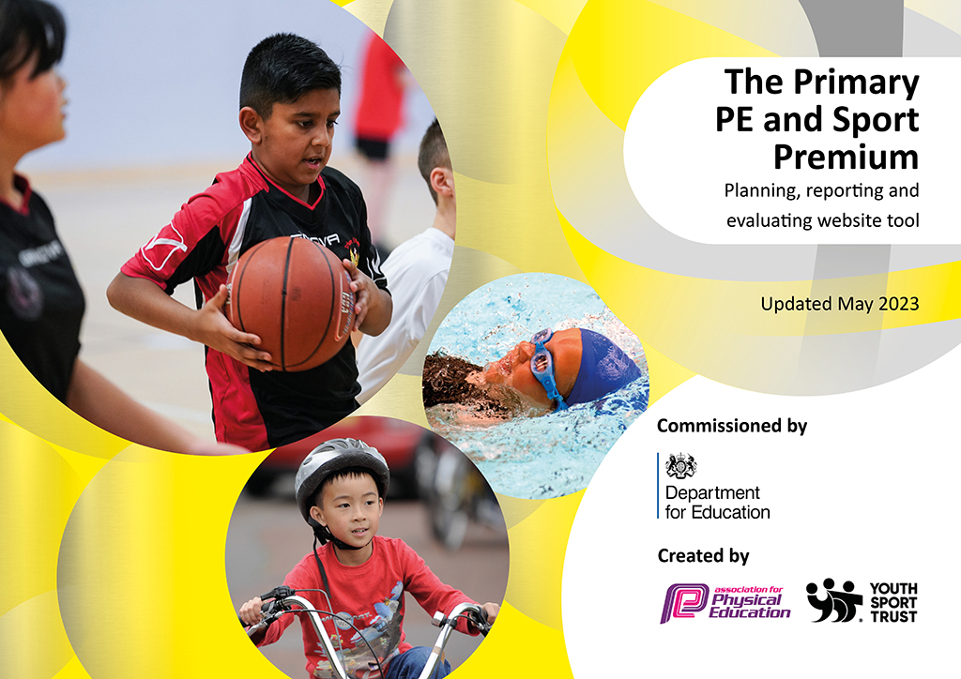
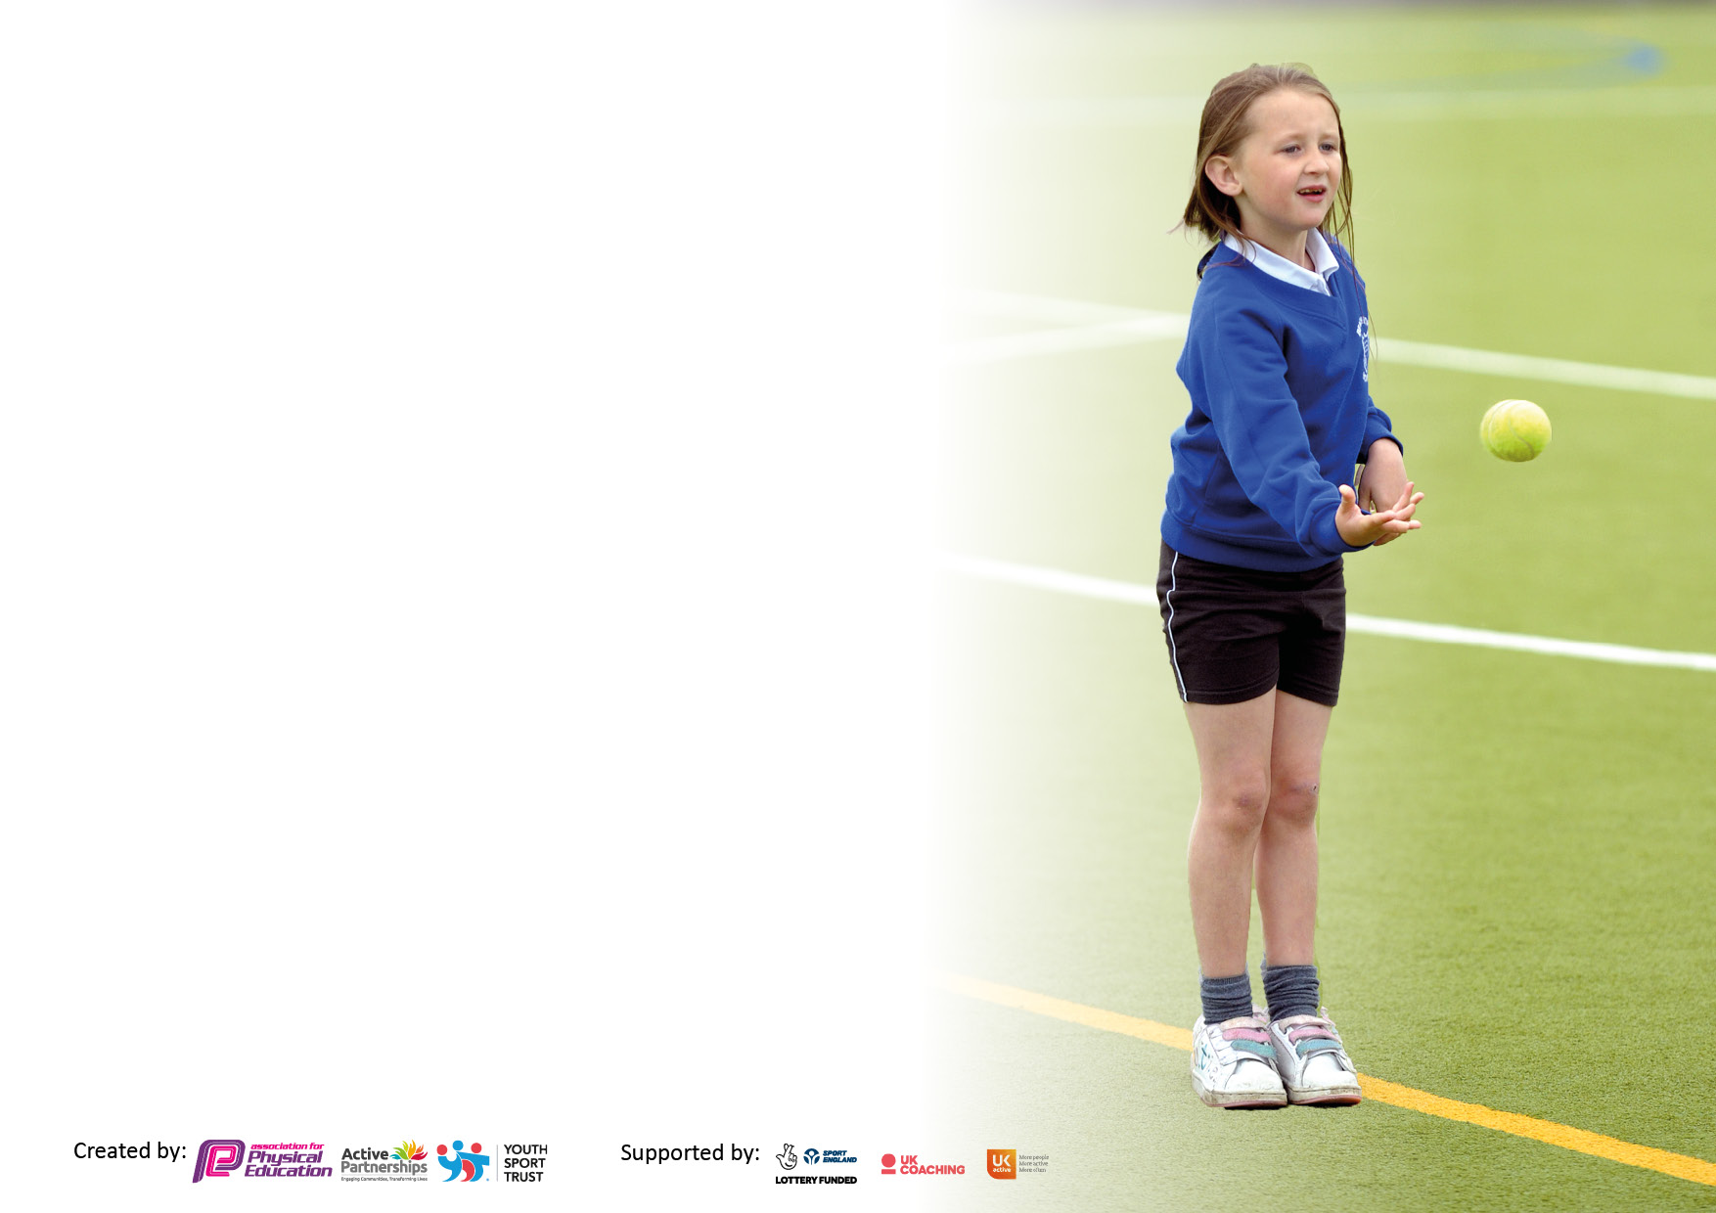

It is important that your grant is used effectively and based on school need. The Education Inspection Framework makes clear there will be a focus on ‘whether leaders and those responsible for governors all understand their respective roles and perform these in a way that enhances the effectiveness of the school’.

Under the Quality of Education Ofsted inspectors consider:
Intent - Curriculum design, coverage and appropriateness
Implementation - Curriculum delivery, Teaching (pedagogy) and Assessment
Impact - Attainment and progress

To assist schools with common transferable language this template has been developed to utilise the same three headings which should make your plans easily transferable between working documents.

Schools must use the funding to make additional and sustainable improvements to the quality of Physical Education, School Sport and Physical Activity (PESSPA) they offer. This means that you should use the Primary PE and sport premium to:

- Develop or add to the PESSPA activities that your school already offer
- Build capacity and capability within the school to ensure that improvements made now will benefit pupils joining the school in future years
- The Primary PE and sport premium should not be used to fund capital spend projects; the school’s budget should fund these.

Please visit gov.uk for the revised DfE guidance including the5keyindicatorsacrosswhichschoolsshoulddemonstrate an improvement. This document will helpyoutoreviewyourprovisionandtoreportyourspend.DfEencouragesschools to use this template as an effective way of meeting the reporting requirements of the Primary PE and Sport Premium.

We recommend you start by reflecting on the impact of current provision and reviewing the previous spend.

Schools are required to publish details of how they spend this funding, including any under-spend from 2021/2022, as well as on the impact it has on pupils’ PE and sport participation and attainment. The funding should be spent by 31st July but the DfE has stated that there will be no clawback of any unspent money so this can be carried forward into 2023/24.

We recommend regularly updating the table and publishing it on your website throughout the year. This evidences your ongoing self-evaluation of how you are using the funding to secure maximum, sustainable impact. Final copy must be posted on your website by the end of the academic year and no later than the 31st July 2023. To see an example of how to complete the table please click HERE.

Details with regard to funding
Please complete the table below.

Total amount carried over from 2021/22 | £ 0
Total amount allocated for 2021/22 | £ 18000
How much (if any) do you intend to carry over from this total fund into 2022/23? | £
Total amount allocated for 2022/23 | £ 18000
Total amount of funding for 2022/23. Ideally should be spent and reported on by 31st July 2023. | £ 18000
Swimming Data
Please report on your Swimming Data below.

Meeting national curriculum requirements for swimming and water safety.

N.B. Complete this section to your best ability. For example you might have practised safe self-rescue techniques on dry land which you can then transfer to the pool when school swimming restarts.
Due to exceptional circumstances priority should be given to ensuring that pupils can perform safe self rescue even if they do not fully meet the first two requirements of the NC programme of study
What percentage of your current Year 6 cohort swim competently, confidently and proficiently over a distance of at least 25 metres?  N.B. Even though your pupils may swim in another year please report on their attainment on leaving primary school at the end of the summer term 2023.  Please see note above | 97%
What percentage of your current Year 6 cohort use a range of strokes effectively [for example, front crawl, backstroke and breaststroke]?  Please see note above | 97%
What percentage of your current Year 6 cohort perform safe self-rescue in different water-based situations? | 97%
Schools can choose to use the Primary PE and sport premium to provide additional provision for swimming but this must be for activity over and above the national curriculum requirements. Have you used it in this way? | No

Action Plan and Budget Tracking
Capture your intended annual spend against the 5 key indicators. Clarify the success criteria and evidence of impact that you intend to measure to evaluate for pupils today and for the future.

Academic Year: 2022/23 | Total fund allocated: | Date Updated:
Key indicator 1: The engagement of all pupils in regular physical activity – Chief Medical Officers guidelines recommend that primary school pupils undertake at least 30 minutes of physical activity a day in school |  |  |  | Percentage of total allocation:
 |  |  |  | 1.5% = £275
Intent | Implementation |  | Impact
Your school focus should be clear what you want the pupils to know and be able to do and about  what they need to learn and to  consolidate through practice: | Make sure your actions to achieve are linked to your intentions: | Funding allocated: | Evidence of impact: what do pupils now know and what can they now do? What has changed?: | Sustainability and suggested next steps:
Daily mile to continue with every class tasking part, with focus on keeping a healthy lifestyle and the benefits of it.  Year 6 ‘Mini Coaches’ to deliver lunch time clubs and activities to younger children.  New sports equipment for more active play times and for Mini Coaching sessions.  To increase the intake for after school and lunch time clubs. | Timetabled daily mile runs for each class to continue embedding this extra physical activity.  South Ribble coaches to give training to staff and children (all of Year 6).  Survey of KS1 for what activities they would like to play during lunch times.  Timetable created to ensure Mini Coaches deliver activities to a large range of children in the infants.  Equipment bought from the guidance of South Ribble and based on the survey results.  Sports Coach and Mini Coaches (overseen by teachers) to conduct a survey to find out what activities children would like to participate in.  To structure a time to include more participation in clubs. | £0  £75  £200  £0 | Children are more aware of the benefits of being more physically active  Children from Key Stage 1 have gained a great deal from these games and activities with the focus being their fundamental skills.  Equipment bought has been a great addition as it has been purposely used just for key stage one.  Survey revealed a lot more sports would like to be included for Key Stage 1 children. | To build on this success to guide children to achieving milestone awards next year (e.g. marathon awards after 26 miles completed).  More training for the Year 6 mini coaches to lead activities, not just in the summer term but at other times in the year.  All sports equipment to be reviewed termly.  To timetable more key stage one children for time to be with the mini coaches and as a lunch time club.
Key indicator 2: The profile of PESSPA being raised across the school as a tool for whole school improvement |  |  |  | Percentage of total allocation:
 |  |  |  | 47% = £8450
Intent | Implementation |  | Impact
Your school focus should be clear what you want the pupils to know and be able to do and about  what they need to learn and to  consolidate through practice: | Make sure your actions to achieve are linked to your intentions: | Funding allocated: | Evidence of impact: what do pupils now know and what can they now do? What has changed?: | Sustainability and suggested next steps:
To train up the staff and children to become Mini Coaches, as a leadership role.  Forest school leader to be fully qualified, with more resources bought to enhance this part of the curriculum. First aid training  To complete another year of ‘Tough Kidder’, a PTFA event to raise money for school.  To use Super Learning Day to promote new sports and activities. | South Ribble coaches to deliver a one-day training course on how to become a play leader.  Use assemblies to promote the achievement of young children during these sessions.  Forest school leader to achieve level 3 this year.  New resources bought for Forest School.  Timetable all of Year 1 and 2 to take part in forest school activities every afternoon  To work with the PTFA on improving our Tough Kidder event, based on Tough Mudder, involving an obstacles race for the whole school to take part in.  The school council to devise a Super Learning Day plan which includes new activities that the whole school to enjoy. | £75 (included above already)  £900 for training  £350 for first aid  £7000  £0  £200 | Year 2 have really enjoyed these sessions and being nominated as good sports people has helped to raise PESSPA profile more.  Forest school has been an excellent addition to our school, giving the children the chance to build character values.  Tough kidder is always a success with the children and has now become an annual tradition enjoyed by all.  Super Learning Day is a welcomed return. It gives the Year 6s a great opportunity for leadership, as well as new skills and sports to be learned on this day. | To include Key Stage 1 in more mini coaching sessions earlier on in the year.  To continue to improve the provision of Forest School. To use the sport premium money to help with further projects.  To continue to work with the PFTA to keep this event an exciting, fun and active experience.  To continue this event next year with a new school council promoting its benefits.

Key indicator 3: Increased confidence, knowledge and skills of all staff in teaching PE and sport |  |  |  | Percentage of total allocation:
 |  |  |  | 44% = £7925
Intent | Implementation |  | Impact
Your school focus should be clear | Make sure your actions to | Funding | Evidence of impact: what do | Sustainability and suggested
what you want the pupils to know | achieve are linked to your | allocated: | pupils now know and what | next steps:
and be able to do and about | intentions: |  | can they now do? What has
what they need to learn and to |  |  | changed?:
consolidate through practice:
To improve the transition of Year 2 to Year 3 (KS1 to KS2) focussing on fundamental skills.  To continue assessing all children through Lancashire’s PE Passport app.  To improve how the staff deliver high quality PE sessions.  To continue to use our Sports Coach to work alongside all teachers to deliver high quality PE lessons. | PE coordinator to work with the Year 3 teacher on creating extra support for those needing support with fundamental skills.  PE coordinator to receive training on how to improve the use of the PE Passport app for the whole school.  PE coordinator to then train staff on how the app can benefit planning, through formative and summative assessments.  Organise training from South Ribble on how to improve inclusion in PE lessons for all.  PE lead and Sports Coach to work together on improving the offer we give for PE across each year group. | £0  £350  £75  £7500 | The extra support has been conducted in the mornings and has helped the children to improve their fundamental skills.  The close assessments made this year has allowed teachers to adapt the lessons for each child.  Teachers now have more ideas of how to adapt lessons for SEN children.  Each class has been given time for CPD with the sports coach and PE lead to improve the quality of lessons. | To assess the fundamental skills of this year’s Year 2 class and continue to work alongside the year 3 teacher for a seamless transition.  Next year we will have more assessment information about each child which will allow the school to see progress scores.  To share good practice with each other on how to improve inclusion for PE lessons.  To continue to use both sports coach and PE lead to improve the quality of lessons.
Key indicator 4: Broader experience of a range of sports and activities offered to all pupils |  |  |  | Percentage of total allocation:
 |  |  |  | 0% = £0
Intent | Implementation |  | Impact
Your school focus should be clear | Make sure your actions to | Funding | Evidence of impact: what do | Sustainability and suggested
what you want the pupils to know | achieve are linked to your | allocated: | pupils now know and what | next steps:
and be able to do and about | intentions: |  | can they now do? What has
what they need to learn and to |  |  | changed?:
consolidate through practice:
To use Super Learning Day to include new sports and activities for all children.  To provide more after school and lunch time clubs with a broad range of sports and activities.  To increase the participation of less active children and SEN children. | School council, along with PE coordinator and the Sports Captains, to devise a plan to include new sports and activities for Super Learning Day.  Mini coaches and Sports Coach to have a timetabled slot for each year group.  To timetable more lunch time clubs which gives access to all children, including SEN and less active children. | £150 (included above)  £0  £0 | New sports were introduced for all children to experience. These new sports/games could be adapted and included into future PE lessons.  More children have been involved in clubs this year, especially lunch times where we see 100% participation.  More focus has been on including children who are SEN or less active. The result has been an increased intake in after school clubs and breakfast clubs. | To continue with new and updated equipment for all sports. To use South Ribble’s offer of Yoga and Mindfulness course for Key Stage 2 in 2023-24.  Sport clubs for Year 5/6 has always been a priority but more clubs for lower key stage 2 and key stage 1 to be planned in for next year, led by our staff.  To plan in new activities that enable SEN and less active children to take part at intra and inter-school level.

Key indicator 5: Increased participation in competitive sport |  |  |  | Percentage of total allocation:
 |  |  |  | 7.5% = £1350
Intent | Implementation |  | Impact
Your school focus should be clear | Make sure your actions to | Funding | Evidence of impact: what do | Sustainability and suggested
what you want the pupils to know | achieve are linked to your | allocated: | pupils now know and what | next steps:
and be able to do and about | intentions: |  | can they now do? What has
what they need to learn and to |  |  | changed?:
consolidate through practice:
Sports Captains and Mini Coaches to lead intra competitions during lunch times.  Increase the number of children attending both intra and inter competition. | Mini coaches to create mini intra competitions for Year 2.  Using South Ribble school games organisers, and in partnership with Hutton and All Hallows’ high schools, St Oswald’s will take part in various competitions across the year. | £0  £1000 to South Ribble  £350 for new Netball competition | Year 2 have enjoyed the events and have mentioned how they would like them to continue.  100% of children in Year 6 represented St Oswald’s this year, with 80% taking part in 2 or more.  25% of Year 5s have represented the school also.  We have also achieved the highest success rate at our school as we finished:  1st in Football  1st in Rugby  1st in Athletics  2nd in Netball  2nd in Swimming  2nd in Girls Football | To continue more intra competitions for all of key stage 1.  To use more staff to reach 100% of Year 6 representing the school with more year groups involved.

Signed off by
Head Teacher: | Mrs B. Wood
Date: | 11.07.23
Subject Leader: | Mr J. Mears
Date: | 11.07.23
Governor: | Mrs Smith
Date: | 11.07.23

