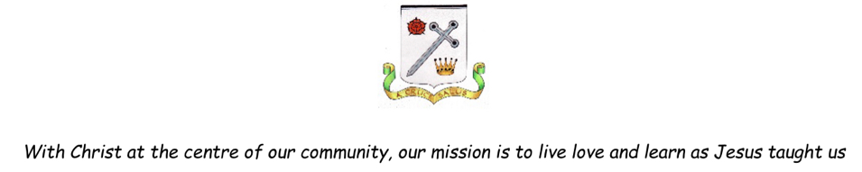

Geography Progression in Key Skills

Year Group | Key Skills
EYFS  Understanding the World  People, Culture and Communities | Communication: talk about the features of their immediate environment and other places – familiar and those they have learn about.  Mapping: recognise, know about and describe features of different places – their immediate environment / other familiar places / places they have learnt about through non-fiction texts, stories, maps, visits, visitors, etc.  Fieldwork: look closely at similarities and differences between their immediate environment and different places they have visited, learnt about through books or websites, etc. Talk about what features are the same and what are the differences.  Enquiry: comment and ask questions about their immediate environment, other places which are familiar to them, and places they have learnt about.  Use of Technology: use technology and IT equipment (e.g. camera, iPad, video/video clips, apps, visualisers or the internet) to make observations or find information about their immediate environment, different locations and places.
Year 1 | Draw, speak or write about simple geographical concepts e.g. garden, route map, place in a story.  Ask and answer simple geographical questions such as what, where, who e.g. what is it like to live in this place?  Describe some similarities and differences when studying places and features e.g. hot and cold places of the world.  Use simple fieldwork and observational skills when studying the geography of their school and its ground including human and physical features.  Use a range of sources such as simple maps, globes, atlases and images at different scales.  Locate land and sea on maps.  Use simple electronic globes and maps.  Know that maps give information about places in the world (where and what).  Use directional and locational language to describe features and routes e.g. left/right, forward/backwards.
Year 2 | Create their own simple maps and symbols.  Describe similarities, differences and patterns e.g. comparing their lives with those of children in other places and environments.  Identify seasonal and daily weather patterns.  Use a range of sources such as maps, globes, atlases and aerial photos to identify features and places as well as to follow routes.  Use simple compass directions.  Use cameras and audio equipment to record geographical features, changes, differences, e.g. weather. Seasons, vegetation, buildings, etc.  Use aerial photos and plan perspectives to recognise landmarks and basic human and physical features.  Know that symbols mean something on maps.  Find a given OS symbols on a map with support.  Look down on objects and make a plan e.g. classroom or playground.
Year 3 | Express opinions on environmental issues and recognise how people can affect the environment both positively and negatively.  Communicate geographical information through a range of methods including the use of ICT.  Identify similarities, differences, patterns when comparing places and features.  Use a range of sources including digital maps, atlases, globes and satellite images to research and present geographical information.  Use the right compass points.  Recognise some Ordnance Survey symbols on maps.  Make comparisons with their own lives and their own situation with other places around the world.  Observe, measure and record the human and physical features of the local area using a range of methods e.g. sketch maps, cameras.  Make and use simple route maps and maps of small areas with features in the correct place.
Year 4 | Express opinions on environmental issues and recognise that other people may think differently.  Identify and describe similarities, differences and patterns when investigating different places, environments and people.  Observe, record and explain physical and human features of the environment.  Use a range of sources including digital and Ordnance Survey maps, globes and satellite images to research and present geographical information.  Recognise some standard Ordnance Survey symbols on maps.  Link features of maps to photos and aerial views.  Use the eight points of a compass.  Make links between features observed in the environment to those on maps and aerial photos.  Use the zoom facility on digital maps to locate places at different scales.  Make use of geography in the news.
Year 5 | Ask and respond to questions that are more causal e.g. why is that happening in that place? Could it happen here?  Recognise geographical issues affecting people in different places and environments.  Observe, measure and record human and physical features using a range of method including sketch maps, cameras and digital technologies e.g. data loggers.  Use a wide range of maps, atlases and digital maps to locate places and features studied.  Relate different maps to each other and to aerial photos.  Interpret and use thematic maps.  Use latitude and longitude on a globe or atlas.  Communicate geographical information in a variety of ways including maps, diagrams, writing at increasing length.  Use appropriate search facilities when locating places on digital/online maps and websites.  Collect and present geographical data electronically e.g. through electronic questionnaires and surveys.
Year 6 | Ask and respond to questions that are more causal e.g. what happened in the past to cause that? How likely is it to change in the future?  Use a wide range of maps, atlases, globes and digital maps to locate countries and features studied.  Relate different maps to each other and to aerial photos.  Create sketch maps using symbols and keys.  Use the scale bar on maps.  Observe, measure and record human and physical features using a range of methods including cameras and other digital technologies e.g., data loggers.  Use more precise geographical language relating to physical and human processes.  Start to explain satellite imagery.  Use and interpret live data e.g. weather patterns, location and timing of earthquakes/volcanoes etc.

