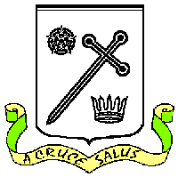
ST OSWALD’S CATHOLIC PRIMARY SCHOOL
SCHOOL UNIFORM
Winter – Boys | Winter – Girls
White shirt and school tie | White blouse and school tie
School sweatshirt with logo | School sweatshirt or sweatshirt cardigan with logo
Grey trousers | Grey pinafore or skirt
Optional school fleece with logo | Optional school fleece with logo
Grey socks | Green or grey tights, white or grey socks
Black school shoes | Black school shoes

Summer – Boys | Summer – Girls
School polo shirt with logo | Green/white gingham dresses
School sweatshirt with logo | School sweatshirt or sweatshirt cardigan with logo
Grey trousers or shorts | White socks
Grey socks | Black school shoes
Black school shoes | Green scrunchies, headbands or bobbles are allowed.

PE KIT FOR ALL PUPILS
Gold PE shirt with logo
Green shorts (stretch shorts for KS1/shadow stripe shorts for KS2)
Black pumps
Only pupils in Y5/Y6 may wear trainers.
Green socks are required for cross-country training.
Black jogging bottoms are allowed in winter for outdoor PE.

ALL UNIFORM IS AVAILABLE FROM JUSTS UNIFORM SHOP, PENWORTHAM
PLEASE NOTE: Summer uniform will be worn with effect from the beginning of the summer term. Winter uniform will be worn with effect from the beginning of the autumn term.

